Italian Pasta - Lesson Plan

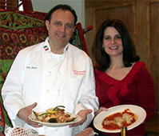 | 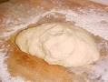

Level: pre-intermediate-intermediate

Objectives:

1. developing:
- cultural awareness
- browsing, note-taking and reporting skills
2. acquiring specific vocabulary referring to Italian pasta.

Sites:

http://int.primopiatto.barilla.com/home/htm/home.htm
www.dictionary.com

Procudure
Search the web
Preliminary task: Activation of cultural and linguistic knowledge through questions, such as:

- How many kinds and shapes of pasta do you know?
- Can you guess where excactly pasta was born?
- How is pasta made out of a dough?
- Have you ever eaten spaghetti? If so, do you remember which sauce/s went with it?
- What characterizes the so-called “Mediterranean diet”?
- .....................................................................................................................
The class is divided into four groups. Each group looks for different information about pasta and has a specif task.

Browsing and note-taking

Each group searches the “Barilla” website http://int.primopiatto.barilla.com/home/htm/home.htm and looks for specific information. Group A about the history of pasta; group B about the Mediterranean diet; group C about spaghetti and group D about a spaghetti recipe.
The students are given an electronic word file with the task instructions. They are also told that they can look up any unknown word in the website www.dictionary.com

Group A: History of pasta. Go to the site http://int.primopiatto.barilla.com/home/htm/home.htm
Put the mouse on “the world of Barilla” and click on “to know more”, then click on ”the colour of the sun: a brief voyage through pasta’s history”. Look for information abot the history of pasta and fill in the table

Group B: Mediterranean diet. Go to the site http://int.primopiatto.barilla.com/home/htm/home.htm
click on ”pleasure and well-being”, then click on “ mediterranean diet”, “complete article index” and then on “the mediterraneab diet in springtime”
Look for information about the mediterranean diet and fill in the table

Group C: Spaghetti. Go to the site http://int.primopiatto.barilla.com/home/htm/home.htm
Put the mouse on “the world of barilla” and click on “pasta”. Click on “classic Italian cuts” and put the mouse on “long cuts”, then click on spaghetti and look for information about spaghetti

Group D: Spaghetti. Go to the site http://int.primopiatto.barilla.com/home/htm/home.htm
Put the mouse on “the world of barilla” and click on “pasta”. Click on “classic Italian cuts” and put the mouse on “long cuts”, then click on “spaghetti” and on “recipes that contain spaghetti”. Choose “Spaghetti alla puttanesca and look for information about the recipe.

Task Sheet Group A

History of pasta.

Go to the site http://int.primopiatto.barilla.com/home/htm/home.htm
Put the mouse on “the world of Barilla” and click on “to know more”, then click on ”the colour of the sun: a brief voyage through pasta’s history”. Look for information abot the history of pasta and fill in the table

Origins of pasta and its first appearance in Italy

Read the introduction and the chapter about the origins and decide whether the following statements are true or false  - Marco Polo introduced pasta when he came back from China T F  - Pasta first appeared in the Middle East T F  - They already made pasta in Sicily in 1154 T F  - Pasta first appreared in the valleys of Jordan  - The Etruscans ignored pasta T F  - The Greeks and the Romans considered pasta “flat dough cut into strips T F | Read the chapter “From Sicily to Genoa” and take notes about the following information  Practice of drying pasta  Origin of “maccheroni”

Task Sheet Group B

Group B: Mediterranean diet. Go to the site http://int.primopiatto.barilla.com/home/htm/home.htm
click on ”pleasure and well-being”, then click on “ mediterranean diet”, “complete article index” and then on “the mediterraneab diet in springtime”
Look for information about the mediterranean diet and fill in the table

Write the following words next to each picture:

Pepper Courgette Asparagus Aubergine Carrot Fresh Peas Radish
Then for each vegetable write the relative vitamins, proteins and minerals on the right column

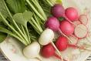
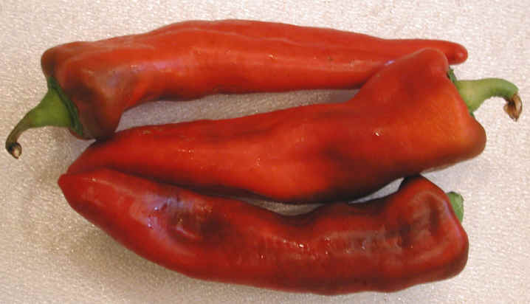
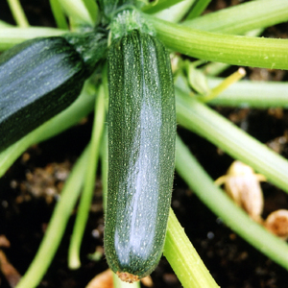
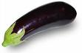
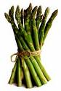
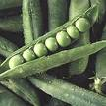
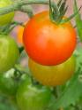
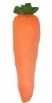

Task Sheet Group C

Group C: Spaghetti. Go to the site http://int.primopiatto.barilla.com/home/htm/home.htm
Put the mouse on “the world of barilla” and click on “pasta”. Click on “classic Italian cuts” and put the mouse on “long cuts”, then click on spaghetti and look for information about spaghetti

Read the text on spaghetti and take notes on the following information

Origin of the name

Shape

Sauces

Task Sheet Group D

Group D: Spaghetti. Go to the site http://int.primopiatto.barilla.com/home/htm/home.htm
Put the mouse on “the world of barilla” and click on “pasta”. Click on “classic Italian cuts” and put the mouse on “long cuts”, then click on “spaghetti” and on “recipes which contain spaghetti”. Choose “Spaghetti alla puttanesca and look for information about the recipe.

Write the ingredients and the quantity next to each picture | Write what you do with each ingredient and number the actions
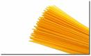
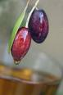
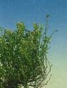
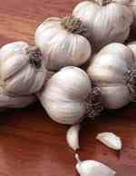
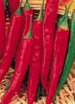
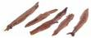
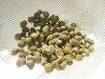
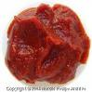
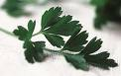
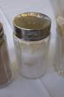

Follow up

Each group will report to the class
A poster will be created

and ........

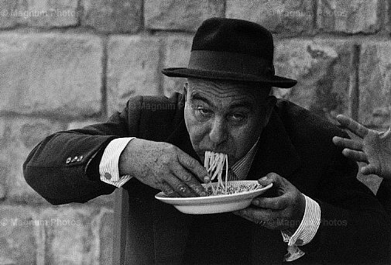

BON APPETIT!

